**COP Exercise 4**

**1. Write a program to find the smallest and greatest number present in the array**

**of integer type.**

class FindLSNumber{

public static void main(String[] args) {

int numbers[] = new int[]{40,35,40,88,72,10,5,28,50};

int smallest = numbers[0];

int largetst = numbers[0];

for (int i = 1; i < numbers.length; i++) {

if (numbers[i] > largetst)

largetst = numbers[i];

else if (numbers[i] < smallest)

smallest = numbers[i];

}

System.out.println("Largest Number is : " + largetst);

System.out.println("Smallest Number is : " + smallest);

}

}

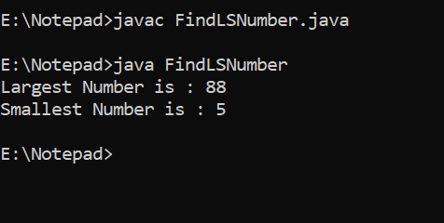

**2. Create an array of 10 elements in 5 rows. And calculate sum of all elements.**

import java.util.Scanner;

class A4Q2

{

public static void main(String arg[])

{

int i = 0, j = 0, ret = 0;

int arr[][] = new int [5][2];

Scanner sobj = new Scanner(System.in);

System.out.println("Enter the elements");

for(i = 0; i < arr.length; i++)

{

for(j = 0; j < arr[i].length; j++)

{

arr[i][j] = sobj.nextInt();

}

}

TestX tobj = new TestX();

ret = tobj.SummationX(arr);

System.out.println("summation of all elements is :" + ret);

}

}

class TestX

{

public int SummationX(int brr[][])

{

int i = 0, j = 0, sum = 0;

for(i = 0; i < brr.length; i++)

{

for(j = 0; j < brr[i].length; j++)

{

sum = (sum + brr[i][j]);

}

}

return sum;

}

}

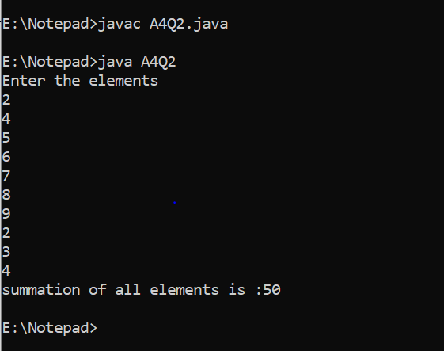

**3. Initialize one String type of array and print the elements using for each loop.**

import java.util.Scanner;

class UsingForEach {

public static void main(String[] args) {

String[] arrData = {"ELON", "MUSK", "RATAN", "TATA", "ADANI"};

System.out.println("\nUsing Foreach loop:");

for (String strTemp : arrData){

System.out.println(strTemp);

}

}

}

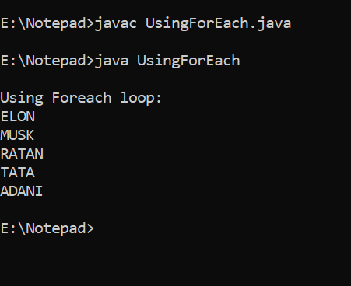

**4. Write a program to print the total number of one-D arrays in a two-D array and**

**the number of elements in every one-D array present in the two-D arrays.**

import java.util.Scanner;

class A4Q4

{

public static void main(String arg[])

{

int i = 0, j = 0, ans1 = 0, ans2 = 0;

int a[] = {4,5,3};

int b[] = {9,8,7};

int c[] = {6,2,1};

int arr[][] = new int[3][];

arr[0]=a;

arr[1]=b;

arr[2]=c;

for(i = 0; i < arr.length; i++)

{

for(j = 0; j < arr[i].length; j++)

{

ans2++;

}

ans1++;

}

System.out.println("Total no of 1D arrays:" +ans1);

System.out.println("Total no of elements:" +ans2);

}

}

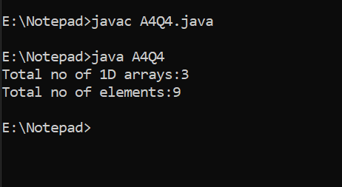

**5. Create an integer type 2-D array of size [3X3]. Take the elements from the**

**user and then calculate the sum of the elements present in the diagonal.**

import java.util.Scanner;

class A4Q5

{

public static void main(String arg[])

{

int i = 0, j = 0, ret = 0;

int size1 = 0, size2 = 0;

Scanner sobj = new Scanner(System.in);

System.out.println("enter the number of 1D arrays");

size1 = sobj.nextInt();

System.out.println("enter the number of elements per array");

size2 = sobj.nextInt();

int arr[][] = new int [size1][size2];

System.out.println("Enter the elements");

for(i = 0; i < arr.length; i++)

{

for(j = 0; j < arr[i].length; j++)

{

arr[i][j] = sobj.nextInt();

}

}

TestX tobj = new TestX();

ret = tobj.SummationX(arr);

System.out.println("summation of all elements is :" + ret);

}

}

class TestX

{

public int SummationX(int brr[][])

{

int i = 0, j = 0, sum = 0;

for(i = 0; i < brr.length; i++)

{

for(j = 0; j < brr[i].length; j++)

{

if(i == j)

{

sum = sum +brr[i][j];

}

}

}

return sum;

}

}

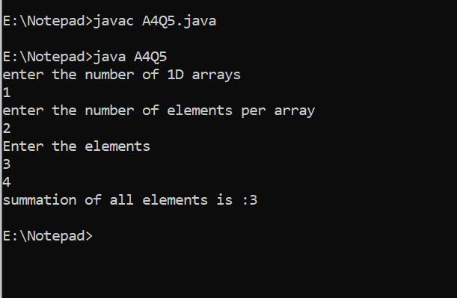

**Write the following using Functions**

1. **to do sum of first N natural numbers.**

import java.util.Scanner;

class A4Q6

{

public static void main(String arg[])

{

int no = 0, ret = 0;

Scanner sobj = new Scanner(System.in);

System.out.println("Enter the Number");

no = sobj.nextInt();

TestX tobj = new TestX();

ret = tobj.NaturalSum(no);

System.out.println("summation of all natural numbers is :" + ret);

}

}

class TestX

{

public int NaturalSum(int num)

{

int i = 0, sum = 0;

for(i = 1; i <= num; i++)

{

sum = sum + i;

}

return sum;

}

}

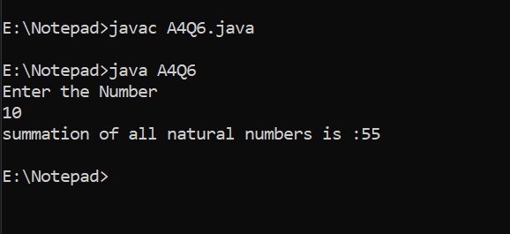

1. **--&gt; to check the given number is odd or even**

import java.util.Scanner;

class A4Q7

{

public static void main(String arg[])

{

int no = 0;

boolean ret = false;

Scanner sobj = new Scanner(System.in);

System.out.println("Enter the Number");

no = sobj.nextInt();

TestX tobj = new TestX();

ret = tobj.CheckNumber(no);

if(ret == true)

{

System.out.println("It is even Number");

}

else

{

System.out.println("It is odd Number");

}

}

}

class TestX

{

public boolean CheckNumber(int num)

{

boolean ans = false;

if((num % 2) == 0)

{

ans = true;

}

else

{

ans = false;

}

return ans;

}

}

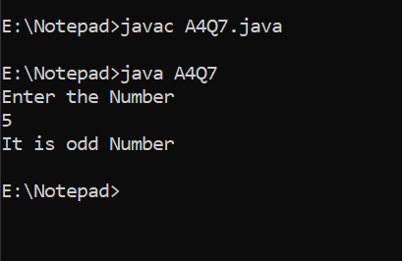

1. **--&gt; Find the greatest number among two numbers**

import java.util.Scanner;

class A4Q8

{

public static void main(String arg[])

{

int no1 = 0, no2 = 0;

int ret = 0;

Scanner sobj = new Scanner(System.in);

System.out.println("enter the first number");

no1 = sobj.nextInt();

System.out.println("enter the second number");

no2 = sobj.nextInt();

TestX tobj = new TestX();

ret = tobj.GreatestNum(no1,no2);

System.out.println("Maximum number is :" +ret);

}

}

class TestX

{

public int GreatestNum(int num1, int num2)

{

int ans = 0;

if(num1 > num2)

{

ans = num1;

}

else

{

ans = num2;

}

return ans;

}

}

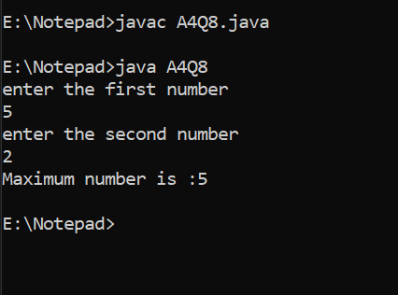

1. **--&gt; keep taking the numbers from user until user prints &#39;y&#39; then print sum of all entered number**

import java.util.Scanner;

class A4Q9

{

public static void main(String arg[])

{

int ret = 0;

TestX tobj = new TestX();

ret = tobj.SumUntil();

System.out.println("Summation is :" +ret);

}

}

class TestX

{

public int SumUntil()

{

int i = 0, no = 0, sum = 0;

char ch = '\0';

boolean flag = true;

Scanner sobj = new Scanner(System.in);

while(flag)

{

System.out.println("enter the number");

no = sobj.nextInt();

sum = (sum + no);

System.out.println("If u want to insert more numbers Enter y");

ch = sobj.next().charAt(0);

if(ch != 'y')

{

flag = false;

}

}

return sum;

}

}

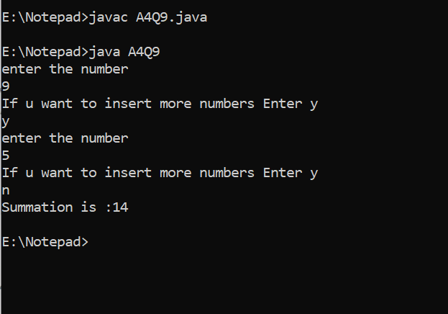

1. **--&gt; to check the number is prime number or not**

import java.util.Scanner;

class A4Q10

{

public static void main(String arg[])

{

TestX tobj = new TestX();

tobj.CheckPrime();

}

}

class TestX

{

public void CheckPrime()

{

int no = 0, i = 0;

boolean flag = true;

Scanner sobj = new Scanner(System.in);

System.out.println("Enter the number");

no = sobj.nextInt();

for(i = 2; i < no ; i++)

{

if((no % i) == 0)

{

flag = false;

break;

}

}

if(flag==true)

{

System.out.println("It is a Prime number");

}

else

{

System.out.println("It is NOT a Prime number");

}

}

}

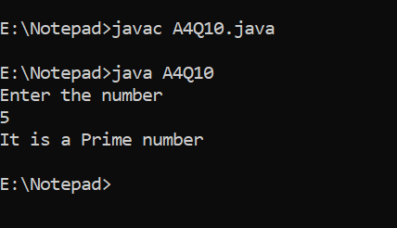

1. **--&gt; to count odd numbers between 1 and 100**

import java.util.Scanner;

class A4Q11

{

public static void main(String arg[])

{

int ret = 0;

TestX tobj = new TestX();

ret = tobj.SumOdd();

System.out.println("Total odd numbers:" +ret);

}

}

class TestX

{

public int SumOdd()

{

int i = 0, icnt = 0;

for(i = 1; i < 100 ; i++)

{

if((i % 2) != 0)

{

icnt++;

}

}

return icnt;

}

}

